Day 8 (Configuring static routers)

in this laboratory I will be configuring static hops between three routers for connectivity. Router 1 G0/1 interface is connected to an network of 192.168.1.0/24 a type C network with one end device and a switch. interface G0/0 is connected to network of 192.168.12.0/24. Router 1 would be configured to have a host name of R1 and two no shut interfaces

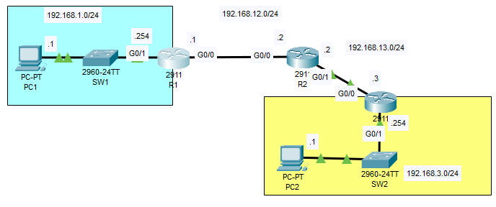

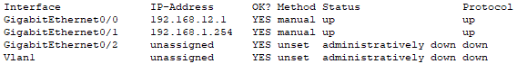

Here we can see that interface g0/0 and g0/1 are up and has assigned an ip address.

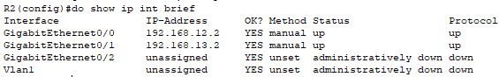

This is router 2 with the same configuration

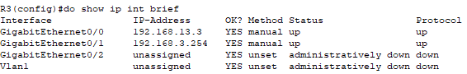  
and for R3

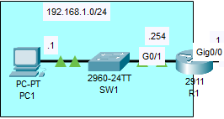Both PC’s on the networks have been assigned IP’s and default gateways on the router.  
  
the R1’s G0/1 is already connected to the network of 192.168.1.0/24 by connecting its interface on the .254 host, this serves as the gateway of the end devices of this network.

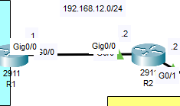Router R1 and R2 are connected, R1’s interface G0/0 and R2’s interface of G0/0 are connected in a network of 192.168.12.9/24 and thus when routing to the next network we must establish a next hop.

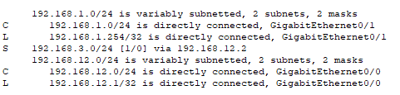

Here we can see the routed interfaces using the command show ip route. This shows both local, connected and static.

Lastly connecting the R3 with the same command would yield the output desired